TO: THE BOARD OF DIRECTORS OF THE REINVESTMENT ZONE NUMBER THREE, CITY OF HOUSTON AND OTHER INTERESTED PARTIES

Notice is hereby given that the Board of Directors of Reinvestment Zone Number Three, City of Houston, Texas (“Zone”) will hold a regular meeting on Thursday, August 27, 2009 at 3:00 p.m. at Houston Technology Center, 410 Pierce Street, third floor conference room, Houston, Texas 77002 to consider, discuss and adopt such orders, resolution or motions, and take other direct or indirect actions as may be necessary, convenient, or desirable with respect to the following matters:

- Minutes of the June 9, 2009 meeting

- FY 2010 Operating and Capital Budgets

- Introduction of Guests and Public Comments

- Next Meeting

- Other Business

- Adjournment
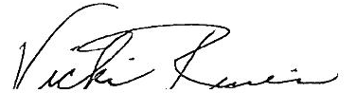

_____________________________________
Vicki Rivers
Executive Director

